AWS Systems Manager
Parameter Store

1. What is Parameter Store?
AWS Systems Manager Parameter Store is a managed service for storing configuration values and lightweight secrets as parameters. Applications, scripts and AWS services can retrieve values by parameter name instead of hardcoding them in source code or configuration files.
EASY DEFINITION Parameter Store keeps application configuration and encrypted values in one central location and controls access with IAM.

Simple example
Instead of writing the database host directly inside an application, store it as /myapp/dev/db-host. The application retrieves the value when it starts. If the host changes, update one parameter rather than editing many files.

Common use cases
- Database host names, ports, environment names and feature flags
- AMI IDs, application paths and deployment configuration
- API tokens or passwords stored as SecureString for lightweight secret use cases
- Values consumed by EC2, Lambda, ECS, CodeBuild, CloudFormation and automation scripts

Important characteristics
Feature | Basic meaning
Regional service | A parameter exists only in the AWS Region where it was created.
Hierarchical names | Paths such as /myapp/dev/db-host organize related values.
IAM control | Policies decide who can create, read, update and delete parameters.
Version history | Each update creates a new version; up to 100 recent versions are retained.
KMS integration | SecureString values are encrypted using a symmetric AWS KMS key.

2. Parameter types
Type | Stored value | Example | Use
String | Single plaintext string | /app/dev/region = ap-south-1 | Normal configuration
StringList | Comma-separated list | /app/dev/azs = ap-south-1a,ap-south-1b | Simple list values
SecureString | KMS-encrypted value | /app/dev/db-password | Passwords, tokens and sensitive values

IMPORTANT The parameter name and metadata are not secret. SecureString encrypts the value. Never put a password or token in the parameter name or description.

String versus SecureString
Question | String | SecureString
Encrypted by Parameter Store KMS integration? | No | Yes
Visible immediately in console/CLI? | Yes | Only after authorized decryption
Typical data | Ports, URLs, environment | Passwords and tokens
Extra permission needed | ssm:GetParameter | ssm:GetParameter plus KMS decrypt permission when applicable

SecureString and KMS
Parameter Store uses AWS KMS to encrypt SecureString values. For a basic lab, use the AWS-managed key alias aws/ssm. Production workloads may use a customer-managed symmetric KMS key when they need stronger control, auditing or cross-account design.
- Only symmetric KMS keys are supported for SecureString.
- Retrieve without decryption to receive encrypted data; use WithDecryption to obtain plaintext when authorized.
- Avoid printing decrypted values in logs, terminals, CI output or screenshots.

3. Parameter tiers
Feature | Standard | Advanced
Best use | Most basic configuration | Larger scale or policy requirements
Maximum parameters per account/Region | 10,000 | 100,000
Maximum value size | 4 KB | 8 KB
Parameter policies | Not supported | Supported
Cross-account sharing | Not supported | Supported
Storage charge | No additional charge | Charges apply
Downgrade | Not applicable | Cannot downgrade to Standard

LAB CHOICE Use the Standard tier for both tasks in this guide. Advanced parameters and high-throughput mode can create charges.

Advanced parameter policies
Advanced parameters can use Expiration, ExpirationNotification and NoChangeNotification policies. These are useful for governance but aren’t required for basic learning.

4. Naming and hierarchy
Use predictable paths so IAM policies and applications can target a group of parameters.
Environment | Suggested parameter names
Development | /myapp/dev/app-name, /myapp/dev/db-host, /myapp/dev/db-password
Test | /myapp/test/app-name, /myapp/test/db-host
Production | /myapp/prod/app-name, /myapp/prod/db-host, /myapp/prod/db-password

Naming recommendations
- Begin with the application, environment and purpose: /application/environment/key.
- Use lowercase names and hyphens consistently.
- Keep development and production parameters in separate paths.
- Do not include sensitive information in the name or description.
- Grant applications access only to the path they require.

5. Task 1 – Create and retrieve a String parameter

Goal
Create a Standard String parameter for an application environment and retrieve it using the console and AWS CLI.

Console steps
- Select Asia Pacific (Mumbai) – ap-south-1 in the AWS Console.
- Open AWS Systems Manager → Parameter Store → Create parameter.
- Name the parameter /venuapp/dev/environment.
- Description: Environment name for Parameter Store lab.
- Tier: Standard. Type: String. Data type: text.
- Value: development.
- Leave tags and parameter policies empty, then choose Create parameter.

Verify in the console
- Open /venuapp/dev/environment from the parameter list.
- Confirm Type is String, Tier is Standard and Version is 1.
- Choose Show value and confirm development.

CLI commands
aws ssm put-parameter --region ap-south-1 \
--name "/venuapp/dev/environment" \
--type "String" --value "development"
aws ssm get-parameter --region ap-south-1 \
--name "/venuapp/dev/environment"

EXPECTED RESULT The response contains the parameter name, String type, value development, version and modification details.

Update and observe versioning
- Edit the parameter and change the value to testing, or use the CLI command below.
aws ssm put-parameter --region ap-south-1 \
--name "/venuapp/dev/environment" \
--type "String" --value "testing" --overwrite

- Open the History tab and confirm that version 2 was created while version 1 remains available.

6. Task 2 – Create and retrieve a SecureString

Goal
Store a sample database password as a Standard SecureString encrypted with the AWS-managed aws/ssm KMS key. Use only a lab value—not a real password.

Console steps
- Open Systems Manager → Parameter Store → Create parameter in ap-south-1.
- Name: /venuapp/dev/db-password.
- Description: Temporary sample password for Parameter Store lab.
- Tier: Standard. Type: SecureString. Data type: text.
- KMS key source: My current account. KMS key ID: alias/aws/ssm or the default AWS-managed key.
- Value: VenuLab@2026! (sample value only).
- Choose Create parameter.

Retrieve securely
- Open the parameter. The value remains hidden until you choose Show decrypted value and have permission.
- Use the CLI without decryption and observe that plaintext isn’t returned.
aws ssm get-parameter --region ap-south-1 \
--name "/venuapp/dev/db-password"

- Retrieve the plaintext only when needed and authorized:
aws ssm get-parameter --region ap-south-1 \
--name "/venuapp/dev/db-password" \
--with-decryption

SECURITY NOTE Do not include the real secret directly in shell history or CI/CD logs. In production, pass sensitive input through an approved secure workflow and restrict both SSM and KMS permissions.

Retrieve a hierarchy
aws ssm get-parameters-by-path --region ap-south-1 \
--path "/venuapp/dev/" --recursive --with-decryption

7. IAM permissions
Parameter Store uses IAM to control actions. SecureString access may also require permission to decrypt with the selected KMS key.
Action | Purpose
ssm:PutParameter | Create or update a parameter
ssm:GetParameter | Read one parameter
ssm:GetParameters | Read multiple named parameters
ssm:GetParametersByPath | Read parameters below a hierarchy
ssm:DeleteParameter | Delete one parameter
ssm:DescribeParameters | List/search parameter metadata
kms:Decrypt | Decrypt SecureString values when required by the KMS design

Least-privilege example
{
"Version": "2012-10-17",
"Statement": [{
"Effect": "Allow",
"Action": ["ssm:GetParameter", "ssm:GetParametersByPath"],
"Resource": "arn:aws:ssm:ap-south-1:ACCOUNT_ID:parameter/venuapp/dev/*"
}]
}

CAUTION Granting access to a hierarchy can expose every parameter below that path. Separate sensitive production paths and test IAM policies carefully.

8. Versions, labels and integration

Versions
Version 1 is created with the parameter. Each value update creates the next version. By default, retrieval without a version returns the latest value.
aws ssm get-parameter --region ap-south-1 \
--name "/venuapp/dev/environment:1"

Labels
A label is a friendly alias for one parameter version, such as production or candidate. Labels are attached after a version exists and can be moved to a different version.
aws ssm label-parameter-version --region ap-south-1 \
--name "/venuapp/dev/environment" \
--parameter-version 2 --labels candidate
aws ssm get-parameter --region ap-south-1 \
--name "/venuapp/dev/environment:candidate"

Common integrations
Service | Example use
EC2 / scripts | Read configuration during bootstrap or deployment
Lambda | Retrieve parameters through SDK or Parameters and Secrets extension
ECS / Fargate | Inject values into task environment configuration
CodeBuild | Load build environment variables from Parameter Store
CloudFormation | Reference SSM parameter values in templates
AppConfig | Use parameters with controlled configuration deployment

9. Monitoring, troubleshooting and cost
Problem | Likely cause | Fix
ParameterNotFound | Wrong name, case, path or Region | Copy exact name and verify Region
AccessDeniedException | Missing SSM IAM permission | Check role/user policy and resource ARN
KMS AccessDenied | Missing decrypt permission or wrong key policy | Check KMS key and kms:Decrypt access
ThrottlingException | Request rate exceeds throughput | Cache values, reduce calls or evaluate paid higher throughput
SecureString still encrypted | WithDecryption not requested | Use --with-decryption when authorized
Overwrite fails | Existing parameter and overwrite not enabled | Use --overwrite intentionally

Monitoring
- CloudTrail records Parameter Store API activity such as PutParameter and DeleteParameter.
- EventBridge can react to parameter changes or policy events.
- Application logs should record retrieval failures but must not print SecureString plaintext.

Basic pricing
Standard parameters with standard throughput have no additional Parameter Store charge. Advanced parameters, advanced API interactions and higher-throughput standard interactions are charged. Customer-managed KMS keys and other integrated services can also have separate charges. Always check current AWS pricing before production use.

10. Parameter Store vs Secrets Manager
Requirement | Parameter Store | Secrets Manager
Primary focus | Configuration plus lightweight secrets | Purpose-built secret management
Standard storage cost | Standard parameters have no additional charge | Secrets and API calls are charged
Automatic secret rotation | Not native as a full managed feature | Built-in rotation workflows for supported services
Parameter hierarchy | Strong path-based organization | Secret naming and tagging
Use when | Configuration, AMI IDs, simple SecureString | Database credentials, rotation and secret lifecycle

INTERVIEW POINT Parameter Store is excellent for configuration and simple encrypted values. Secrets Manager is usually preferred when managed secret rotation and a richer secret lifecycle are required.

11. Interview questions
Q: What is Parameter Store?
A: A Systems Manager capability that stores hierarchical configuration and SecureString values with IAM-controlled access.
Q: What parameter types are available?
A: String, StringList and SecureString.
Q: How is SecureString protected?
A: Its value is encrypted and decrypted through a symmetric AWS KMS key.
Q: What is the default parameter tier?
A: Standard.
Q: Standard versus Advanced?
A: Advanced supports higher limits, 8 KB values, policies and sharing, but charges apply and it cannot be downgraded.
Q: What happens when a value is updated?
A: Parameter Store creates a new version automatically.
Q: How do you retrieve a decrypted secret in the CLI?
A: Use get-parameter with --with-decryption and the required permissions.
Q: Why use hierarchical names?
A: They organize values and enable path-based retrieval and IAM control.
Q: Parameter Store versus Secrets Manager?
A: Parameter Store targets configuration and lightweight secrets; Secrets Manager provides dedicated secret lifecycle and rotation features.

Short interview answer
ANSWER AWS Systems Manager Parameter Store is a regional service for centrally storing configuration and SecureString values. I organize parameters using paths such as /application/environment/key, control access with IAM, and encrypt sensitive values using AWS KMS. Applications retrieve parameters through the console, CLI, SDK or service integrations. Updates create versions, and I use least privilege, avoid logging decrypted values, and select Standard tier unless advanced limits or policies are required.

12. Lab cleanup
Delete both temporary parameters after completing the tasks.
aws ssm delete-parameters --region ap-south-1 \
--names "/venuapp/dev/environment" "/venuapp/dev/db-password"

- Open Systems Manager → Parameter Store and confirm both names are gone.
- If you created any customer-managed KMS key, IAM policy, role, EventBridge rule or log resource specifically for the lab, remove it only after checking that nothing else uses it.
- Do not delete the AWS-managed aws/ssm KMS key.
NOTE After deleting a parameter, AWS requires a short wait before recreating a parameter with the same name.

Official AWS references
- Parameter Store overview: https://docs.aws.amazon.com/systems-manager/latest/userguide/systems-manager-parameter-store.html
- Create parameters in the console: https://docs.aws.amazon.com/systems-manager/latest/userguide/parameter-create-console.html
- Create parameters with the CLI: https://docs.aws.amazon.com/systems-manager/latest/userguide/param-create-cli.html
- SecureString and KMS: https://docs.aws.amazon.com/systems-manager/latest/userguide/secure-string-parameter-kms-encryption.html
- Parameter versions: https://docs.aws.amazon.com/systems-manager/latest/userguide/sysman-paramstore-versions.html
- AWS Systems Manager pricing: https://aws.amazon.com/systems-manager/pricing/

- AWS Parameter Store Simple Lab
- Objective
- Create a String parameter, retrieve its value, update it, and delete it after completing the lab.
- Part 1: Select the AWS Region
- Sign in to the AWS Management Console.
- From the Region selector, choose:
- Asia Pacific (Mumbai) – ap-south-1
- Parameter Store values are regional, so continue using the same Region throughout the lab.
- Part 2: Open Parameter Store
- Search for Systems Manager.
- Open AWS Systems Manager.
- In the left navigation menu, locate Application Management.
- Select Parameter Store.
- Click Create parameter.
- Part 3: Create a String parameter
- Enter the following details:
- Setting | - Value
- Name | - /venuapp/dev/environment
- Description | - Temporary Parameter Store lab value
- Tier | - Standard
- Type | - String
- Data type | - text
- Value | - development
- Leave the following settings unchanged:
- Allowed pattern: Empty
- Tags: Empty
- Parameter policies: Empty
- Click Create parameter.
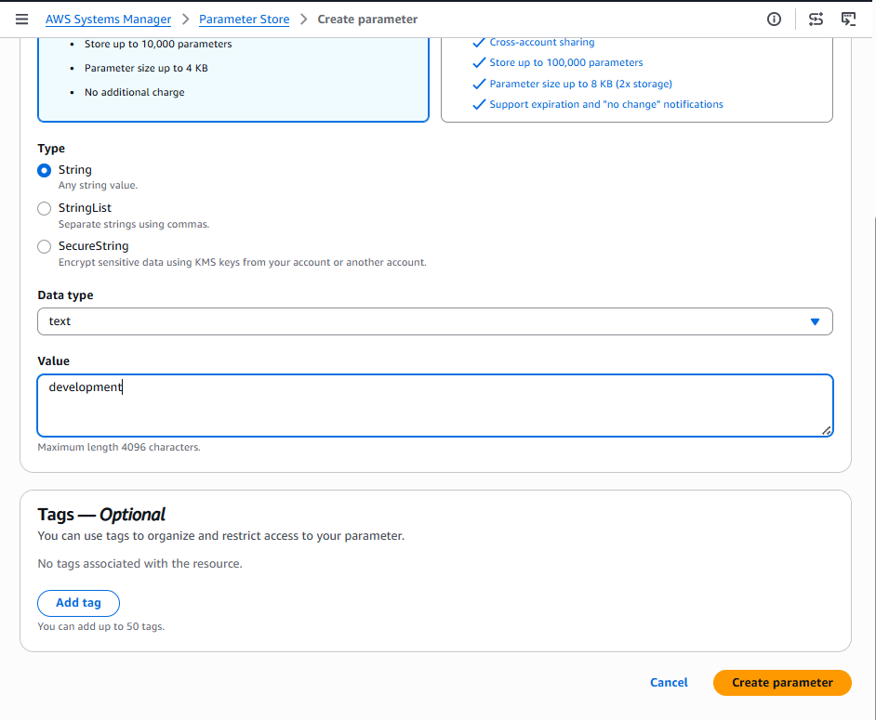
- Expected message:
- Parameter /venuapp/dev/environment created successfully
- Part 4: Retrieve the value in the console
- Return to the Parameter Store list.
- Search for:
- /venuapp/dev/environment
- Click the parameter name.
- Open the Overview or Details tab.
- Click Show value.
- Expected value:
- development
- Confirm these details:
- Property | - Expected result
- Type | - String
- Tier | - Standard
- Version | - 1
- Value | - development

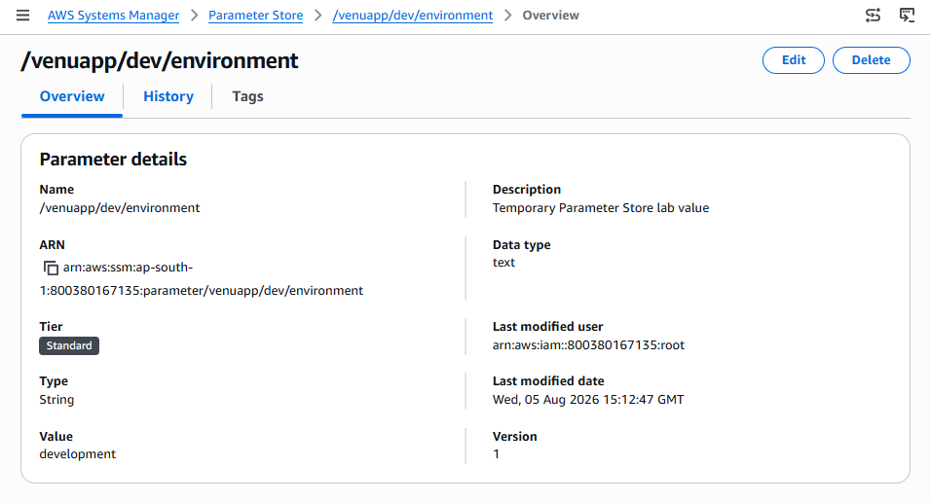
Part 5: Retrieve using AWS CloudShell
- Click the CloudShell icon in the AWS console.
- Wait for the terminal to start.
- Run:
- aws ssm get-parameter \
- --name "/venuapp/dev/environment" \
- --region ap-south-1
- Expected output:
- {
- "Parameter": {
- "Name": "/venuapp/dev/environment",
- "Type": "String",
- "Value": "development",
- "Version": 1
- }
- }
- The output may contain additional fields.
- Part 6: Update the parameter
- Using the console
- Open /venuapp/dev/environment.
- Click Edit.
- Change the value from:
- development
- to:
- testing
- Click Save changes.
- Verify the updated value
- Run:
- aws ssm get-parameter \
- --name "/venuapp/dev/environment" \
- --region ap-south-1
- Expected results:
- Value: testing
- Version: 2
- Each update creates a new parameter version.
- Part 7: Check version history
- Open the parameter in the AWS console.
- Select the History tab.
- Confirm that two versions are displayed:
- Version | - Value
- 1 | - development
- 2 | - testing
- Version 2 should be the current version.
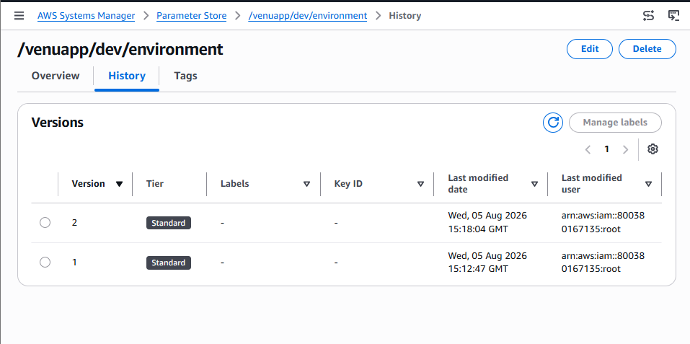
- Part 8: Delete the parameter
- After taking the required screenshots:
- Open Systems Manager → Parameter Store.
- Select /venuapp/dev/environment.
- Click Delete.
- Enter the requested confirmation if displayed.
- Click Delete parameters.
- Alternatively, use CloudShell:
- aws ssm delete-parameter \
- --name "/venuapp/dev/environment" \
- --region ap-south-1
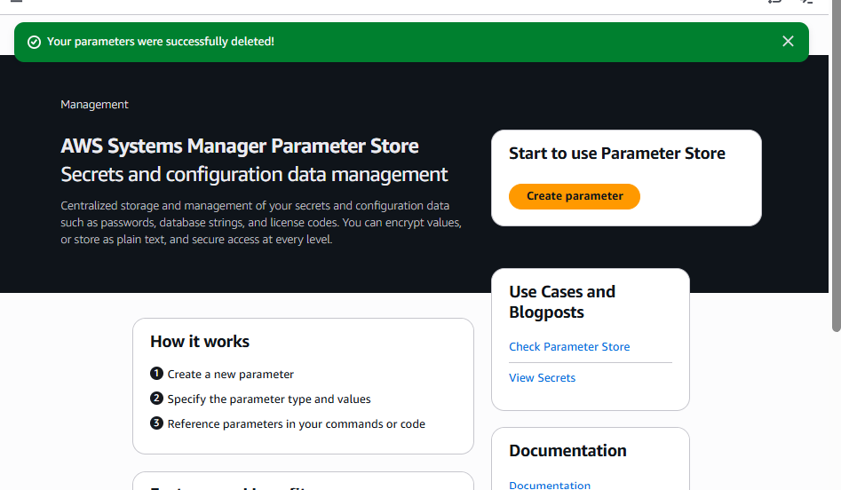
- Final lab result
- You successfully:
- Created a Standard String parameter
- Retrieved it through the console
- Retrieved it using AWS CLI
- Updated its value
- Checked its version history
- Deleted the temporary parameter

